ETL using SSIS Package

Step 1

Staging into ist722_hhkan_oc6_stage

Control Flow of Stage Fudgemart Orders

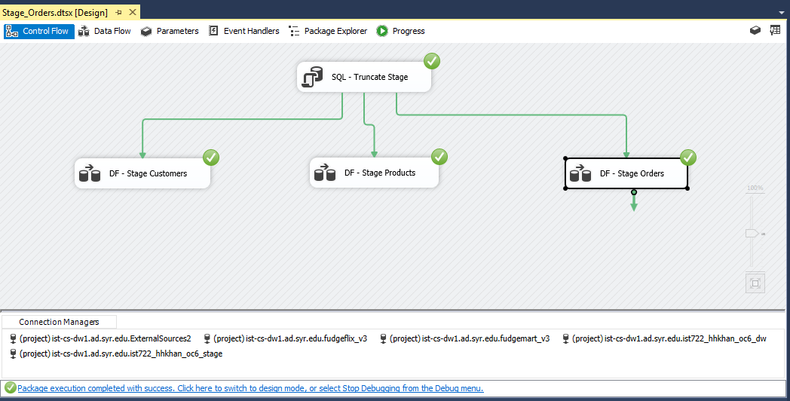

Data Flow of Stage Fudgemart Customer

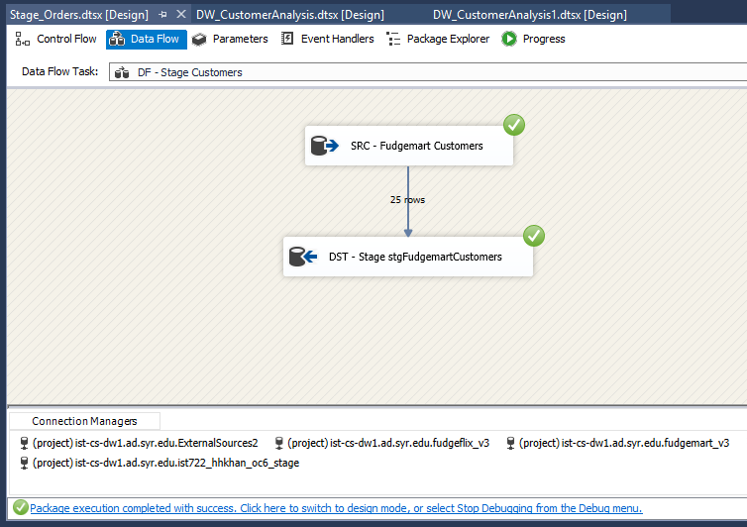

Data Flow of Stage Fudgemart Product

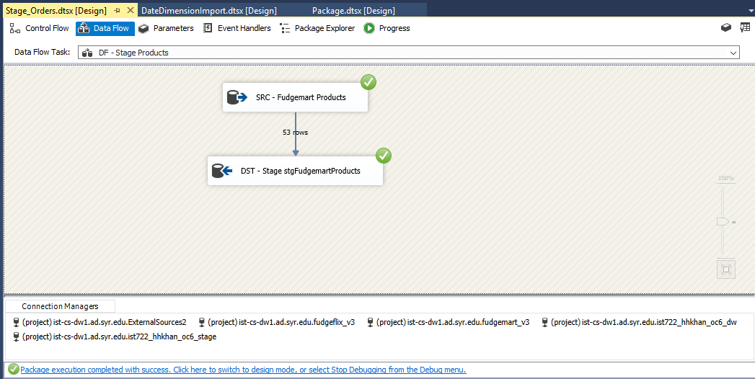

Data Flow of Stage Fugdgemart Orders

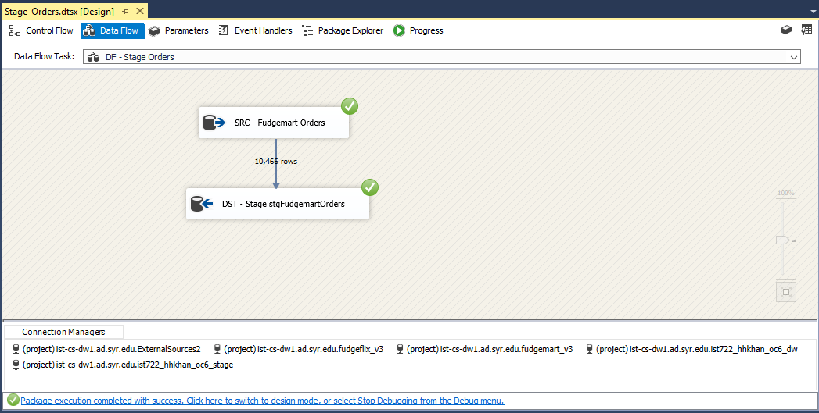

Control Flow of Stage Customer Analysis

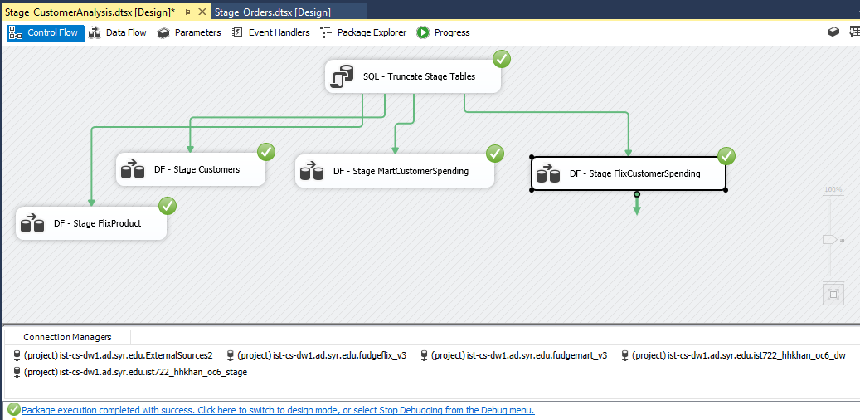

Data Flow of Stage Fudgeflix Customer

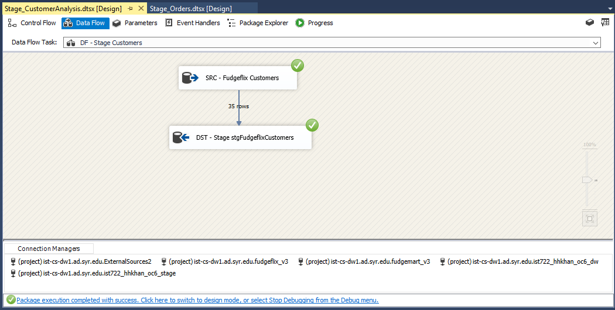

Data Flow of Stage Fudgeflix Product

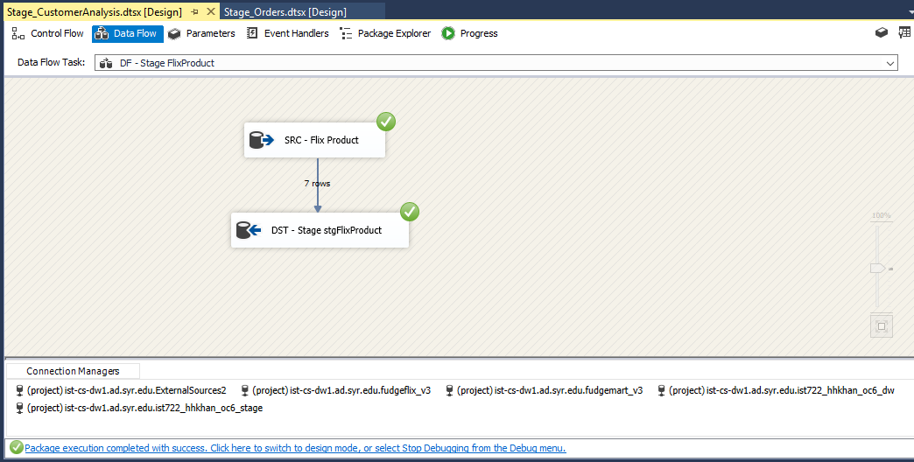

Data Flow of Stage Fudgeflix Customer Spending

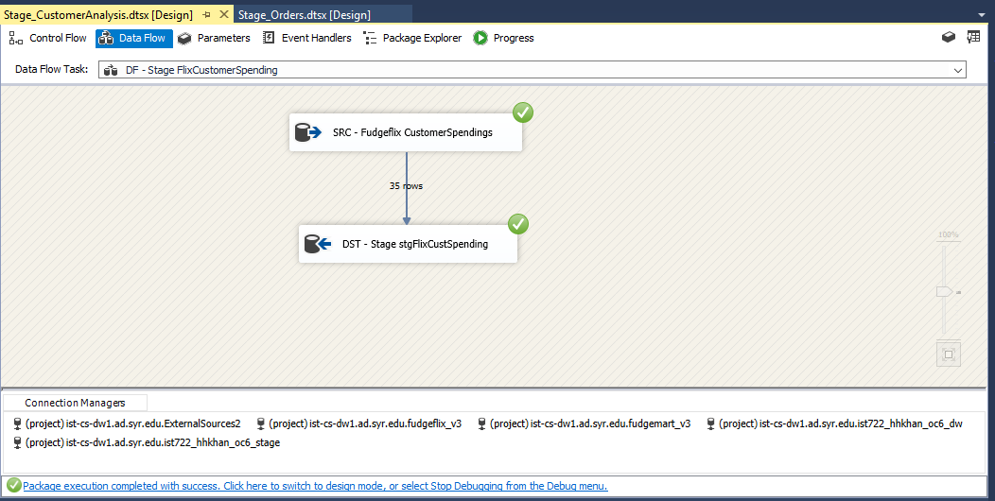

Data Flow of Stage Fudgemart Customer Spending

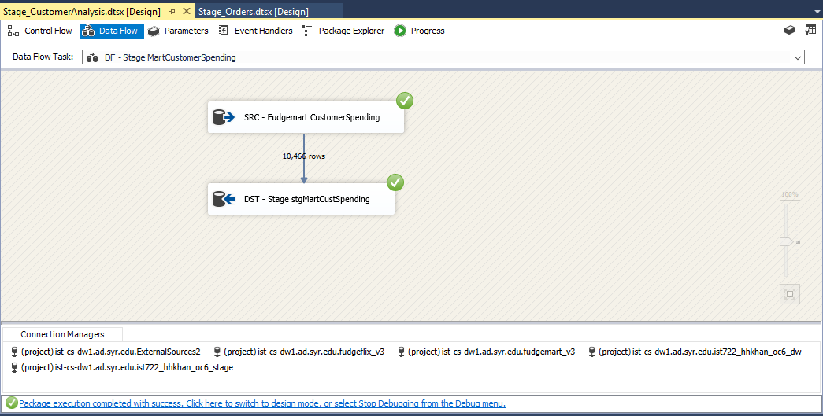

**Step 2**

Loading into ist722_hhkhan_oc6_dw

Control Flow of DW order analysis

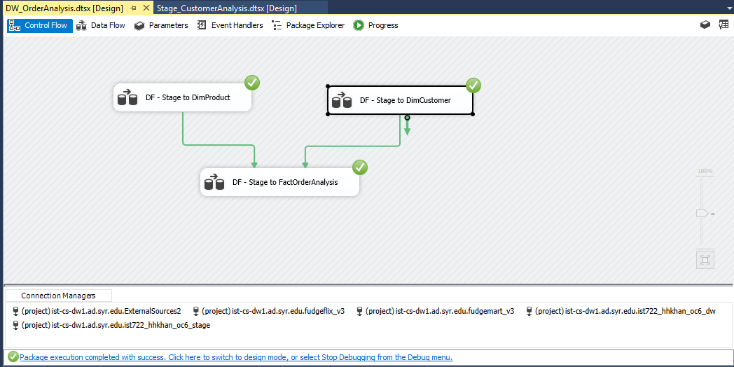

Data Flow of Stage to DimProduct (MartProducts)

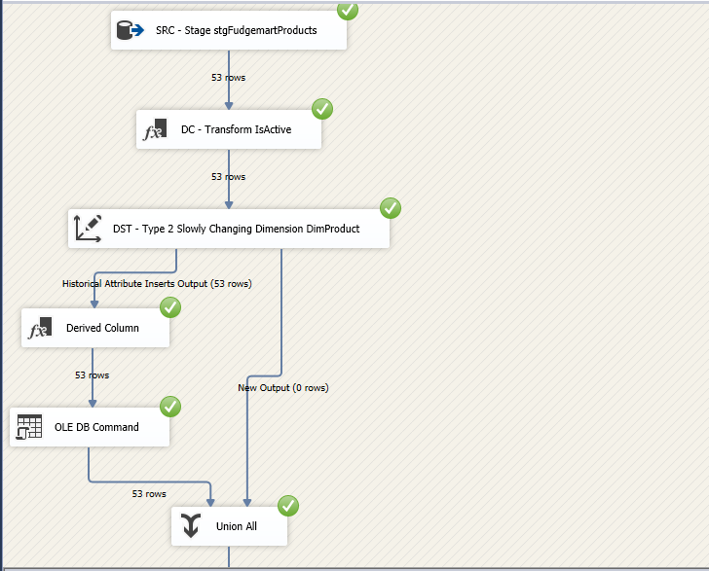

Data Flow of Stage to DimCustomer (MartCustomer)

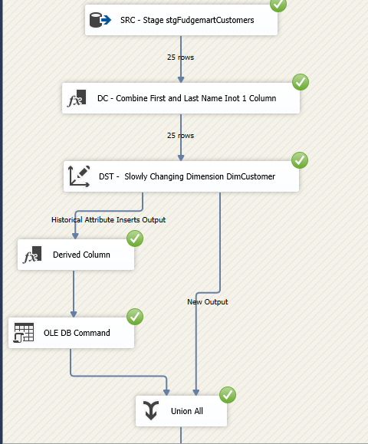

Data Flow of Stage to FactOrderAnalysis

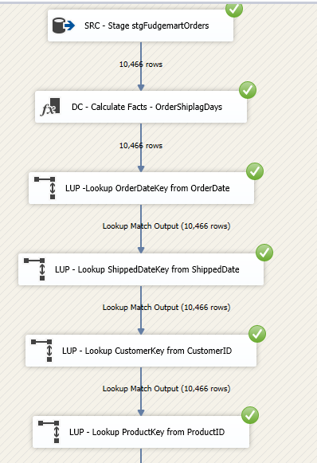

Control Flow of DW Customer Analysis

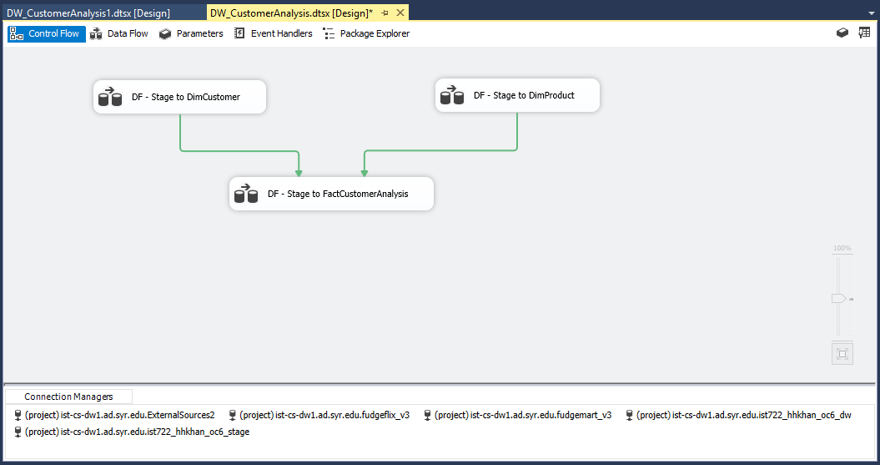

Data Flow of Stage to DimProduct (Flix Product)

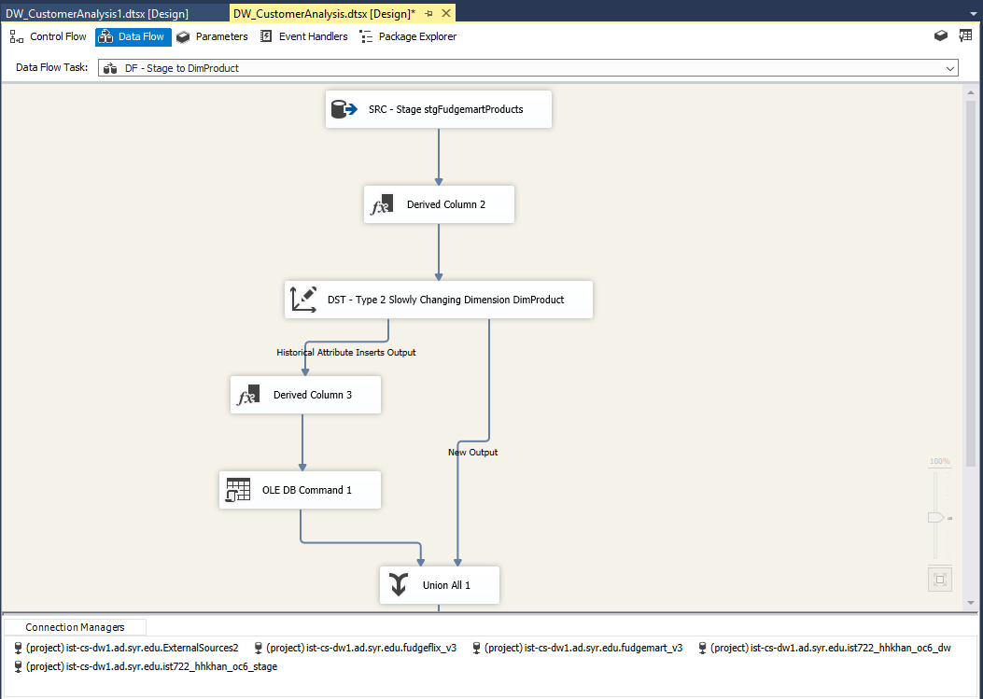

Data Flow of Stage to DimCustomer (Flix Customer)

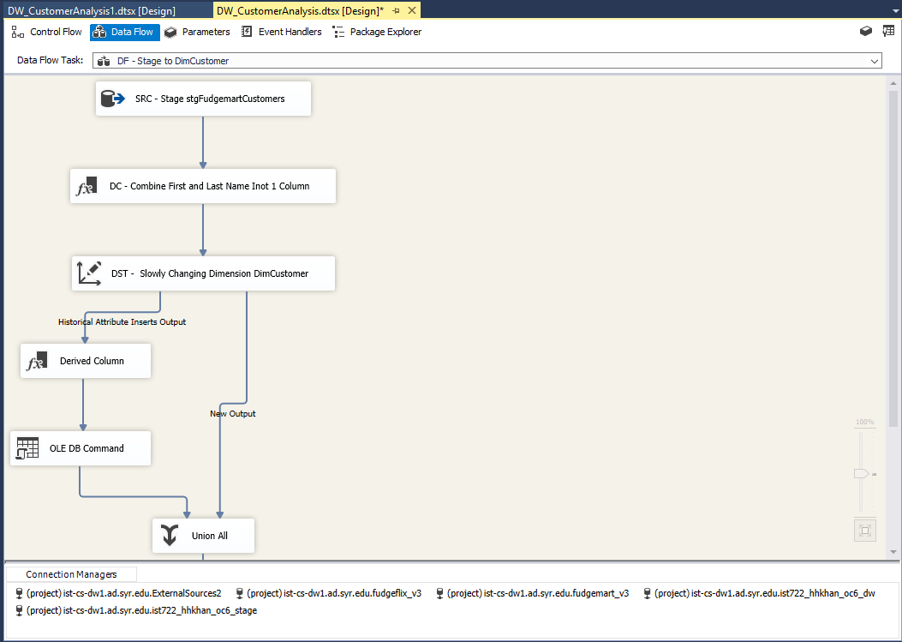

Data Flow of Stage to FactCustomerAnalysis

